Wampum
- String/white belt with white and purple beads (cut from different shells)
- Each string/belt had a different message (meaningful and sincere)
- Iroquois used wampum belts to help them remember the Great Law of Peace.
Great Law of Peace
- Constitution of Great Law (Canada has a Constitution- sets rules for Canadian society)
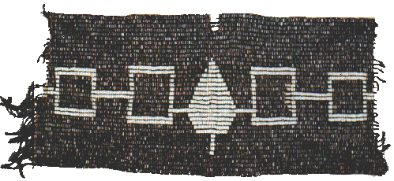
- Describes principles of good living and tells how Confederacy should be organized and ran
- Very long
- Wampum keepers in charge for caring for the wampum and reading it
- Reader passes his hands along belt, bead by bead
- Texture reminds him of events or treaties recorded
- Keepers chosen by clan and trained at young age
- Told in a dramatic and poetic way
- Iroquois women made belts

