May 15, 2014
Activity: Let it Shine
Question: How does blowing air affect air pressure?
Notes: The air moving around the can is at a lower pressure than the still air. This low pressure moving air is pushed quickly around the can towards the flame (by the still air- high pressure).
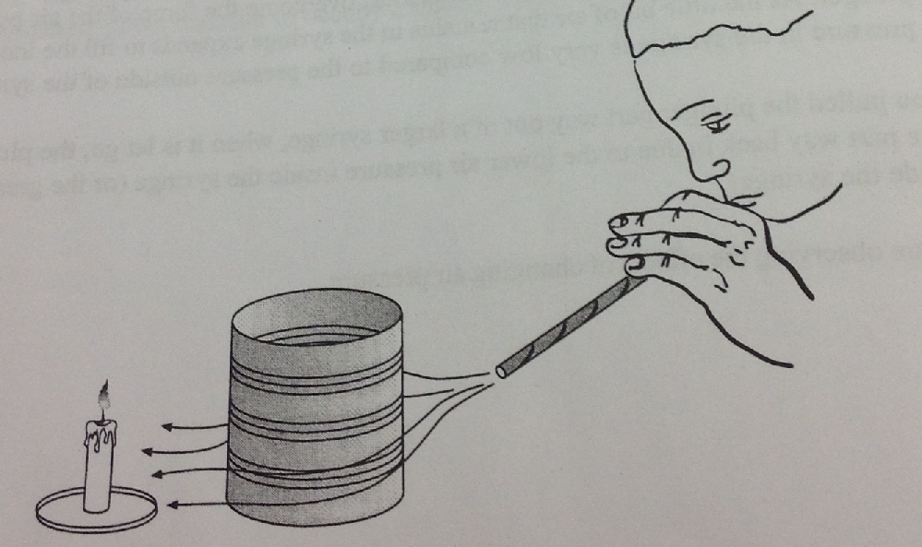
Activity: Raise Up Your Books
Challenge: How can you use air pressure to move your books?
Notes: Air exerts pressure and that pressure can be used to do work. Pneumatic jacks, car jacks, tire pumps and bicycle tires are everyday examples of air pressure at work.

