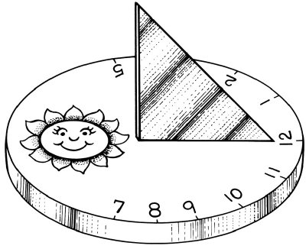
Sundials
Have you ever wondered how people worked out their ideas of telling the time? They used the position of the Sun in the sky. They used sundials.
You can tell the time by looking at the shadow cast by the Sun as it shines on the pointer of a sundial. The proper name for the pointer is a gnomon (said 'nom-on')
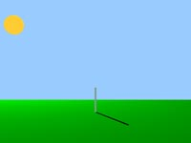
A sundial works by casting a shadow in different positions, at different times of the day. You can try this for yourself by setting up a shadow-stick. You'll notice that at different times of the day, the shadow is in different positions, and it changes length.

The Sun is highest in the sky at midday and casts a short shadow. In the afternoon, when the Sun is lower in the sky, the shadow is longer.
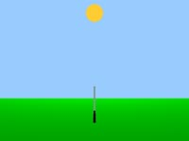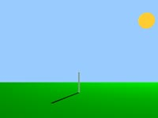
Midday Afternoon
The length of the shadow is also affected by the seasons. Winter shadows are longer than Summer shadows. This is because the Sun is lower in the sky in Winter.
The speed of the shadow depends on the length of the gnomon. For example, if the gnomon is 2 metres tall, the tip of the shadow will move about a third of its height (60cm) in an hour - 1cm per minute. The Eiffel Tower is 300 metres high. The tip of its shadow moves across the ground at a speed of about 1.5 metres per minute. This movement is due to the Earth's rotation.
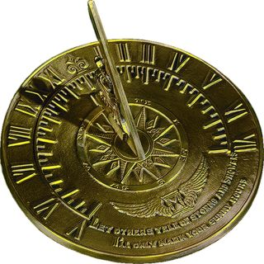
Most sundials just have marks for the daylight hours, when the Sun will actually cast a shadow. However, some show all 24 hours. Noon and midnight appear directly opposite each other, with 6 a.m. and 6 p.m. on either side.
http://www.liverpoolmuseums.org.uk/kids/games-quizzes/sun/index.html

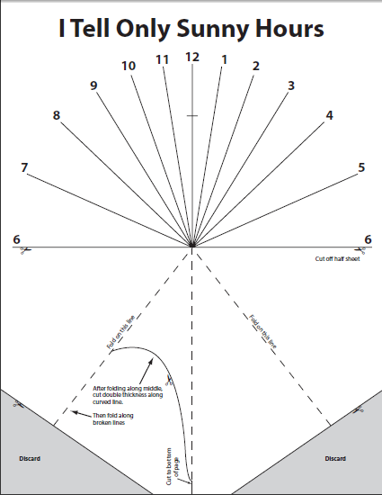
Task:
Create your own sun dial using the NASA “I Tell Only Sunny Hours” handout. Please read the instruction carefully. As well, don’t forget to put your name on your sundial.

Math Extension Activity:
Measure and identify the various angles using the sundial below.
Measure Counter-clockwise | Degrees | Angle Name  (acute, obtuse, right, straight, reflex)
6 to 5
6 to 4
6 to 3
6 to 2
6 to 1
6 to 12
6 to 11
6 to 10
6 to 9
6 to 8
6 to 7
6 to 6

