Reasons for the Seasons
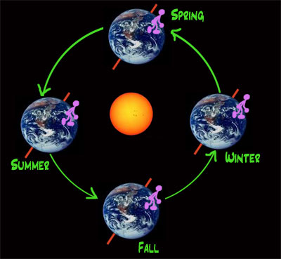
The reason it is sometimes winter and sometimes summer is that the Earth spins on a slightly tilted axis. You can see the red axis in the picture here (though really there is no axis to see; it's a direction, not a real stick).
In the winter, the North Pole is a little further from the Sun, and so the sunlight hits the North Pole at more of an angle, and it has more of the Earth's atmosphere to go through before it gets to the Earth. That lets the area around the North Pole get colder.
In the summer, the North Pole is pointed more toward the Sun, and so the part of the Earth near the North Pole gets more direct sunlight, and becomes warmer.
That's the part with the pink figure on it - the United States and Canada and Europe. If you live in Australia, nearer to the South Pole, then you get more direct sunlight when the pink figure is further from the Sun, and his summer is your winter, and his winter is your summer.
This tilted axis is also the reason why there are more hours of daylight in the summer and fewer hours of daylight in the winter. In the winter, the closer you are to the North Pole, the shorter the days are. At the North Pole, it's just dark all winter. In the summer, the closer you are to the North Pole, the longer the days are. At the North Pole, it is light all summer, with no nights at all.
http://scienceforkids.kidipede.com/physics/weather/seasons.htm

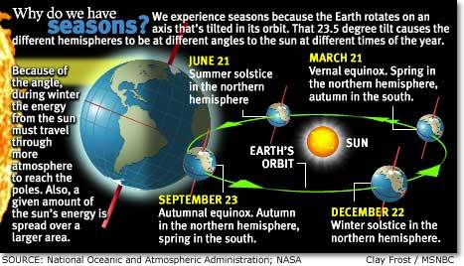
- On or about June 21 – direct rays of the Sun fall on the Tropic of Cancer. This is the LONGEST DAY of the year for us and is called the SUMMER SOLSTICE.
- On or about September 21 – direct rays of the Sun fall on the Equator. This is known as the Autumn or FALL EQUINOX. There is an equal amount of daylight and darkness at the equator on the day of the Equinox.

- On or about December 21 – direct rays of the Sun fall on the Tropic of Capricorn (near Rio de Janero, Brazil). This is the SHORTEST DAY of the year for us and is called the WINTER SOLSTICE.
- On or about March 21 – direct rays of the Sun, once again, fall on the Equator. This is known as the Spring or VERNAL EQUINOX.
Task 1:

- Predict what the seasons would be like it the Earth was NOT tilted, or if the Earth was MORE TILTED.
Not Tilted: ____________________________________________________________________________________________________________________________________________________________________________________________________________________________________________________________________________
More Tilted: ____________________________________________________________________________________________________________________________________________________________________________________________________________________________________________________________________________
Task 2:
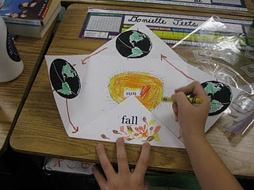
Create your own Seasons Model. Use the sample provided to help guide you. Then, in the blank spaces, write about what you have learned about each season. You may write a paragraph or jot notes for each space.

Extension Activity (Math):
Draw a 23.5 º angle.
Name of angle: ________________

Reasons for the Seasons
