January 18, 2016
Nicolaus Copernicus (1493-1543)
- Scientist who was first to re-introduce idea that the Sun and not the Earth, was the center of the solar system.
What are stars made of?
- Stars are made of very hot gas. This gas is mostly hydrogen and helium, which are the two lightest elements. Stars shine by burning hydrogen into helium in their cores, and later in their lives create heavier elements. Most stars have small amounts of heavier elements like carbon, nitrogen, oxygen and iron, which were created by stars that existed before them. After a star runs out of fuel, it ejects much of its material back into space. New stars are formed from this material. So the material in stars is recycled.
North Star (a.k.a. Polaris)
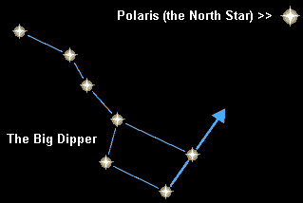
- Moderately bright star found on an imaginary line drawn from pointers of the Big Dipper.
- From the North Star, other stars can be located by using the fist “sky measure” method.
(http://www.education.com/science-fair/article/astronomy_night-sky/)

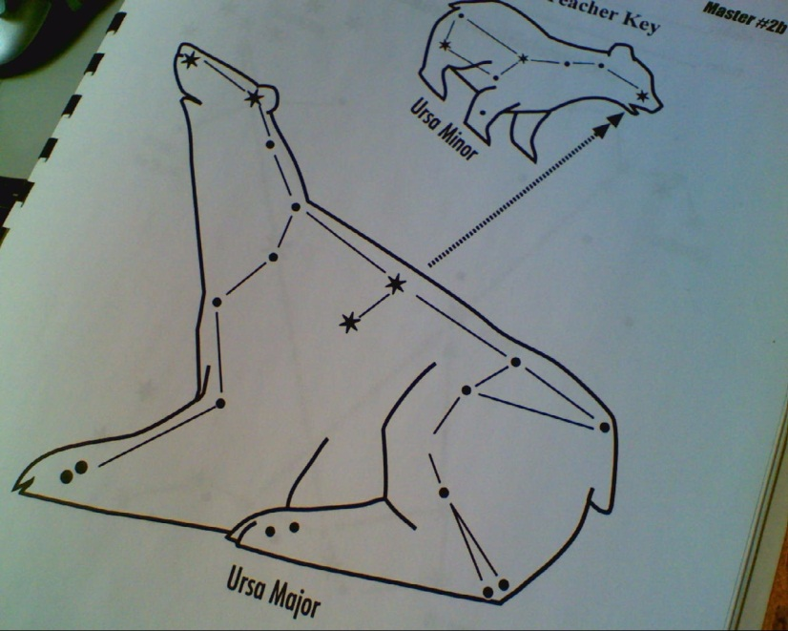
Big Dipper
- 7 brightest stars
- Looks like a cooking pot

- Ursa Major (Big Bear)
- Ursa Minor (Little Bear)

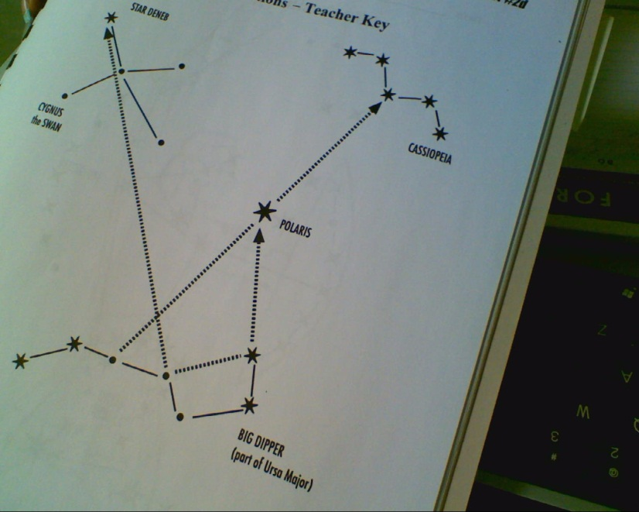
Cassiopeia (W)
- Constellation of Cassiopeia the queen
- Scientists added the 6th star to make the Queen’s throne
- Queen sitting on throne
- Can be seen in the northern sky at any time of the year

Ursa Major, Cassiopeia and Ursa Minor, are circumpolar constellations meaning they circle the north star and can be seen year round.

Orion
- Only visible in the early winter to late spring
