
Starlight, Moonlight?

- Most objects we see in the night sky are stars which are light emitting objects and therefore are sources of energy.
- Relatively small number of objects in the night sky that are seen by reflected light the most visible which is the Moon.
- Planets and their satellites are seen because they reflect light from the sun.
- Stars “twinkle” and planets don’t.
- Stars twinkle because they are pinpoints of light in the night sky and their light is affected by convection currents (movement of molecules within fluids (i.e. liquids, gases)) in our atmosphere.
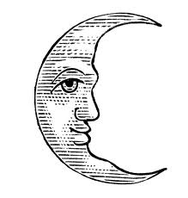
- Planets may appear to be “star-like” in appearance but careful observation should reveal that they don’t twinkle. They are much closer to the Earth and the light that is reflected from their surfaces is much less affected by convection currents in our atmo sphere.

