MOON Facts

- On the average the Moon is VISIBLE for 12 hours a day. It RISES in the EAST and SETS in the WEST.

- The Moon will rise and set approximately 50 minutes later each day.

- To observe the Moon during the day, find out the date of the next full Moon in your local newspaper. Also find the time that the Sun rises.

- As the Sun rises in the east, the full Moon will be setting in the West.

- One day later, the Moon will set 50 minutes after Sun rise (higher in the sky).

- Two days later, the Moon will set 100 minutes after Sun rise (even higher in the sky).

- “Moon” is capitalized when it is used as a proper noun to name the Earth’s satellite. All other “moons” that orbit other planets are satellites and can be referred to by their proper names, or referred to as “moons of a planet” (e.g. moons of Jupitor or Io, Callisto, Ganymede...)

- The moon is about one-fourth the size of the Earth

- The moon moves in an elliptical orbit, about 400 000 km above the earth at an average speed of 3700 km per hour.

- The Moon takes about 27 days (27 days, 7 hours, 43 minutes, 11.6 seconds) to go all the way around the Earth and return to its starting position.

- The moon rotates on its axis once in the same period of time it takes to complete one revolution around the Earth, accounting for the fact that the same portion of the moon is always facing the Earth.

- The moon shows progressively different phases as it revolves around the Earth.

What is a Lunar Month?
A lunar month is the time the moon takes to pass through a complete cycle of its phases and is measured from New Moon to New Moon. A lunar month is about 29.5 days (29 days, 12 hours, 43 minutes, 11.6 seconds)

Why is a Lunar month (29.5 days) longer than the number of days it takes the Moon to orbit the Earth (27.3)?
Whilst the Moon is orbiting the Earth, the Earth is constantly moving because it is orbiting the sun. The Moon therefore travels slightly more than 360° to get from one new moon to the next. Thus the lunar month is longer.

How wide is the Moon?
The Moon has a diameter of 3,476 kilometres.
The surface of the Moon has about the same area as the continent of Africa.

What is the surface of the Moon like?
The surface of the moon has many things on it such as craters, lava plains, mountains, and valleys. Scientists believe the craters were formed around 3.5 to 4.5 billion years ago by meteors hitting the moon's surface.

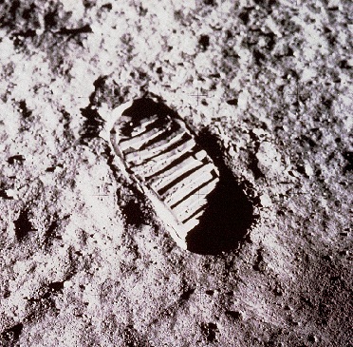
The Moon has no atmosphere
Water was discovered on the moon in November 2009
There is no wind or weather on the moon.
Footprints left on the Moon by Apollo astronauts will remain visible for at least 10 million years because there is no erosion on the Moon.

http://resources.woodlands-junior.kent.sch.uk/time/moon/facts.htm
Why can we see the Moon?
The Moon is not a light source, it does not make its own light.
The moon reflects light from the sun.
We can see the Moon because light from the Sun bounces off it back to the Earth.

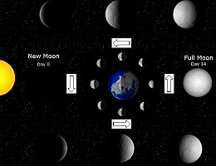
If the Sun wasn't there, we wouldn't be able to see the Moon.
The Sun always lights up (illuminates) one side of the Moon.
The Moon appears to change shape but what we are actually seeing is the Moon lit up by the light from the Sun in different ways on different days.

The Moon and The Tides
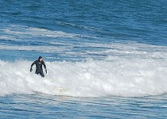
The moon causes many of the tides in the Earth's oceans. This is because of the gravity force between the Earth and Moon.
During full and new moons the gravitational forces of the Sun and Moon combine to produce the highest tides called Spring Tides.
During quarter moons the gravitational forces of the Sun and the Moon oppose each other to produce the lowest tides called Neap Tides.

Did you know?  We always see the same side of the moon. The Moon always keeps the same side pointing towards us so we can never see the 'back' of the Moon from the Earth.  As the moon rotates around the earth, it also rotates around its own axis at the same rate. This is why we always see the same side of the moon.  A few days after new moon, when there is just a very slim crescent, you can sometimes see earthshine on the non-illuminated portion of the Moon. Earthshine is caused by sunlight being reflected off the Earth and falling onto the Moon. | 