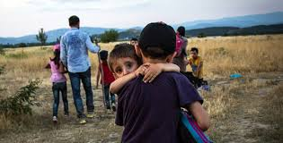
Refugee Crisis
Reflection
By Mrs. Bujas

Justice is feeling safe in one’s country. Citizens can comfortably walk out their front door and get to their destination without being harmed.

Justice is not having the basic necessities to live such as food, water, shelter, and clothing. As a result, refugees become ill, malnourished, and cold.

Justice is having the Canadian Charter of Rights and Freedoms. We are able to have peaceful assemblies, have a voice, follow any religion, move wherever we’d like and many more.

Justice is not solving problems through violent measures and hurting the innocent. According to World Vision, 320 000 lives have been taken, and many of them are children. That is disgustingly too many.

Justice is being compassionate and welcoming to new people. It’s about understanding each other and developing empathy for one another. As a school community, we are welcoming refugees by providing household items to furnish their new home.

Justice is not being forced to leave your home, family, friends, and items that are most valuable to you due to war in one’s country. It saddens me to know that people work hard to build relationships and buy new things, and all of sudden, BOOM! It’s all gone.

“Justice cannot be for one side alone, but must be for both.” ~ Eleanor Roosevelt.

