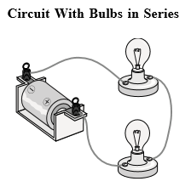
This circuit has two bulbs connected in SERIES; i.e. one is wired directly to the other, in a row. The electrical current must pass through the nichrome wire element of the first bulb and then through the nichrome wire of the next. The result is that the first bulb will be brighter than the other because the nichrome element in the first bulb converts some of the electrical energy into heat and light, so there is less current available for the second bulb. If a third bulb was to be connected into the series circuit there may not be enough current left to light up the last bulb. It must also be noted that when one bulb is removed from its holder, or if one bulb is burned out in a series circuit, the circuit is broken and none of the bulbs will light up.
An example of a real life application is decorative or Christmas lights (older models), where if one bulb fails, the entire string will not light. Security systems are another applicable example.

