Activity: Soil Samples Notes
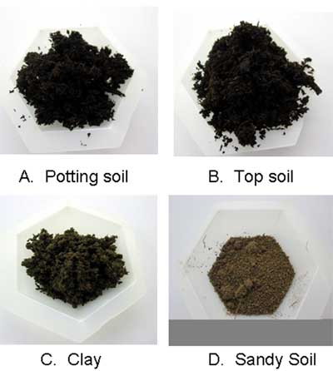
The colour of soil indicates the materials that the soil is made up of. Soil rich in humus will be very dark in colour. Soil from an unpaved parking lot may contain very little humus and a lot of sand and pebble to keep the water from collecting there. Police compare soil samples found at the scene of the crime with those found on a suspects clothing, shoes or in their car.

The grittiness of soil can be tested by wetting a small amount of the soil and rubbing it between your thumb and two fingers. Soil made up of very small particles will feel smooth. Soil containing sand or larger, coarser particles will feel rougher and gritty.

You will get clearer results smelling the soil when it is damp.

Other material found in the soil may include insect parts, fur, hair, bones, branches, etc.

ACTIVITY: MYSTERY FUN

Materials:
- Masters #21 and #22

Procedure:

- Read the story (Master #21) and replace any of the words or phrases in capital letters with an appropriate vocabulary term from this unit. E.g. STUDYING THE LETTER SHAPES N HANDWRITING is replaced with graphology.

- Reread the story using the new terminology.

- Complete Master #22 (matching).

