Name: __________________________
Date: ___________________________

Observing Differences in Shoe Prints

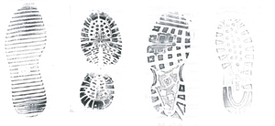
When observing shoe prints, you may...
- compare length and width of prints made by someone’s shoes.
- compare variances in the treads of various peoples’ shoes and any cut outs or other marks that make it possible to identify a person’s shoe.
- compare and measure the length of stride.
- compare prints made by students moving forward, backward and sideways. How do you know which direction the subject is moving?
- compare prints (depth and distance apart) made when moving at different gaits (walking, running, hopping, skipping, jumping) by different people.
- compare differences in depth of one print, at various points (heel, toe) within the print.
- observe overlapping prints. Which one(s) came first?
- observe prints made when carrying weight.
- compare prints made under dry conditions versus wet conditions.

Parts of a shoe print made while running should be deeper than a print made while walking. The walking print should be clearer and more uniform.

Depending on the running style of the suspect, there may be only deep toe marks from pushing off or deep heel marks from landing.

The length of stride increase with speed. The farther apart successive prints are, the greater the speed.

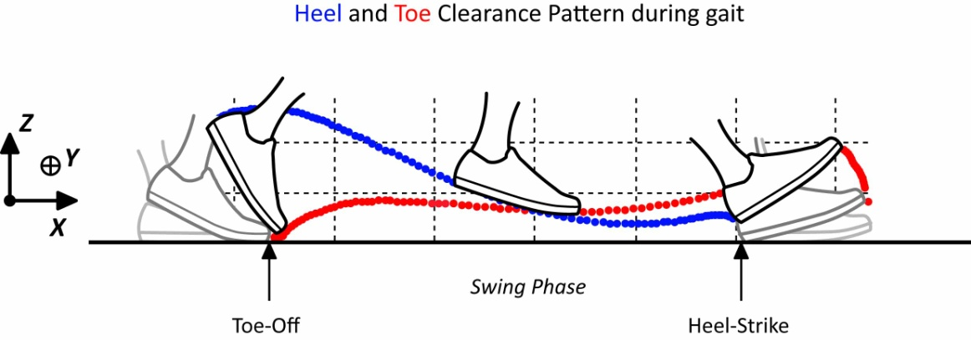

CLASSIFYING SHOE PRINTS

Shoe prints can be categorized in a number of ways:
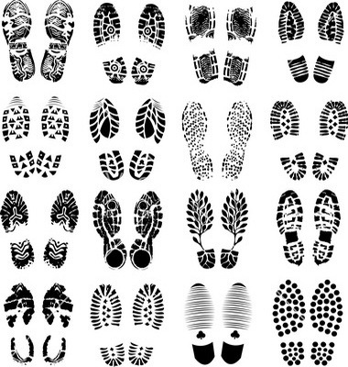
- heels
- visible treads
- no treads
- wide treads
- narrow treads
- size of shoe print
- pointed toe
- rounded toe
- etc.

ACTIVITY: TAKE YOUR MEASURE

Question: Is the length of a human foot a good indicator of height?

Materials:
- 30 centimeter ruler
- Tape measure
- Meter stick (optional)
- Graph paper
- Master #7

Procedure:
- In pairs, measure one another’s height and length of foot. A standing measurement will be more accurate.
- Collect data from nine other students.
- Create a line graph with the acquired data, label both x and y axis, and create a title.

Is the length of a human foot a good indicator of height?
________________________________________________________________________________________________________________________________________________________________________________________________________________________________________________________________________________________________________________________________________________________________________

Name: __________________________
Date: ___________________________

Activity: Animal Tracks

You will observe a variety of tracks and make an INFERENCE about what kind of animal may have made such tracks.

Procedure:

- Use Master #3 and examine the front and back paws of each animal. What are your OBSERVATIONS? What kind of animal made such tracks (INFERENCE)?
- Match each set of tracks to an animal from the list below. In each case, explain why you think these tracks belong to the chosen animal. Provide detailed observations and reasons as to why you could infer that it is a wolf, dog, etc.

Reasoning is crucial! INFERENCES must be based on OBSERVATION.

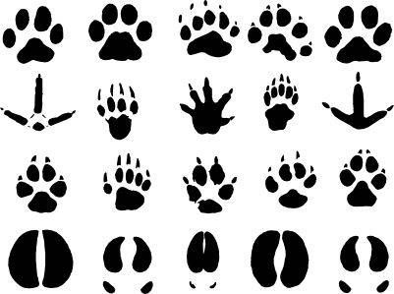
Animals:
- Cat
- Mouse
- Deer
- Magpie
- Dog or coyote
- Rabbit

- Animal C is an unknown creature. Mr. Smith thinks it is a squirrel. Do you agree with Mr. Smith? Why or why not?
________________________________________________________________________________________________________________________________________________________________________________________________________________________________________________________________________________________________

Name: __________________________
Date: ___________________________

Activity: Speedy Tracks

You will observe differences in animal tracks and determine possible rates of speed.

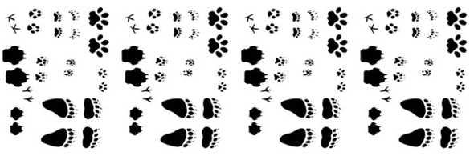

Procedure:

- Use Master #4a. Examine the tracks and at which speed the skunk, weasel, and mink are moving. Note that for the lynx (Box A), badger (Box B), you need to INFER and then record the speed in the box.
- Study the lynx tracks on Master #4a and record your observation on Master #4b.
- Look at your observations you have made and INFER how the lynx was moving (based on your observation).
- Make an INFERENCE about how fast you think the animal is travelling on Master #4a (Box A).
- Complete Master #4a and #4b.

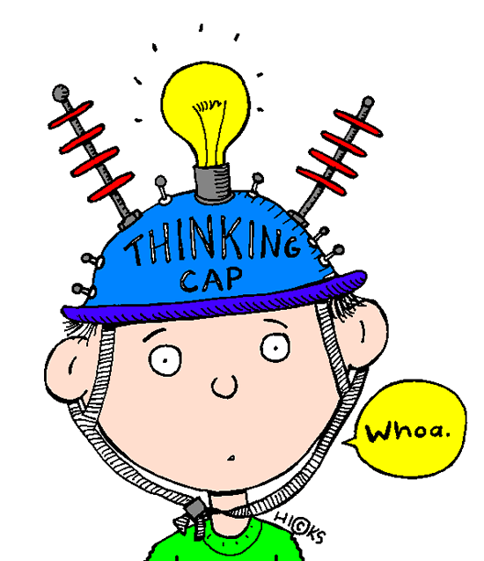
Keep in mind...

An OBSERVATION is the collection of data using the five senses.
An INFERENCE is the interpretation of what is observed.

Interesting YouTube Videos:
- http://www.youtube.com/watch?v=pPi4LsJuiFo (Animal tracks)

- http://www.youtube.com/watch?v=rLLzCswVd6Y (How to identify walks in animal tracking)

