Name: __________________________
Date: ___________________________

Activity: Graphologists Game

You will examine samples of handwriting to look for differences.

Materials:
- Pencils
- Paper/index card
- Magnifying glasses

Procedure:
Part A
- Try to copy the handwritten message below on an index card.

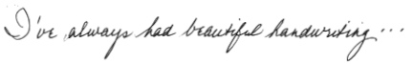
- Once you’ve finished copying the message in handwriting, exchange your copied handwriting message with a partner.

- Then, attempt to make forgeries of the samples you have been given by your peers on the back of this sheet.

- When the forgery attempt is complete, meet as partners/group and generate responses to the following questions:

- What characteristics or traits did you try to copy to make your writing the same as the original??
- What letters were difficult to copy? Why?
- Which letters were easy to copy? Why?
PART B
- Complete Master #16. Which suspect wrote the note from the crime scene? 1, 2, 3, 4, 5, or 6?
LEARN ABOUT DIFFERENT CODES (different ways of communicating)!

- Morse
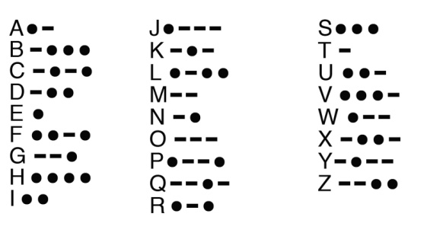
- Maritime
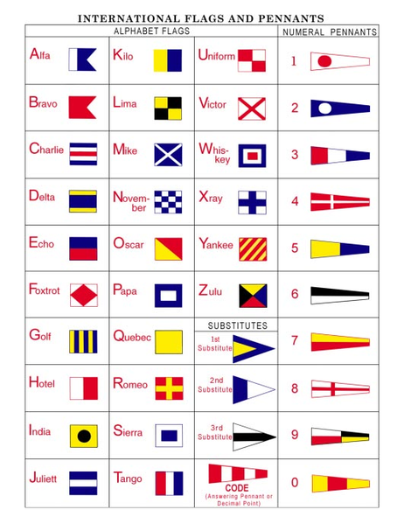

- Braille
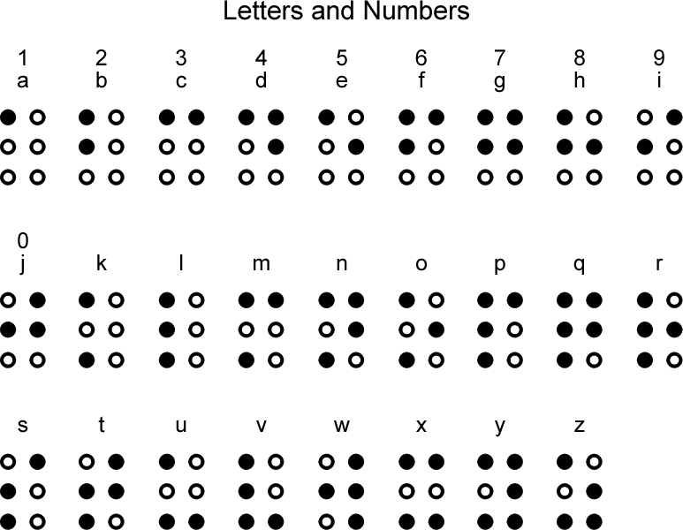

- Pig Latin
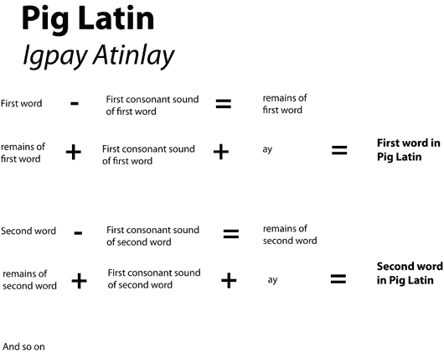

- Color
- Number Codes

Try this!
One technique used to discover a handwritten message is the old-fashioned movie detective ploy of “press and rub.” Have one person write a message on the top sheet of a pad of paper and remove the top sheet. Then, take the pad, using a pencil, gently shade the area which has writing indentations. If the first person has pressed hard enough when writing, the message should become clear to the second person.

Activity: Graphologists Game Notes

Some of the indicators used in comparing handwriting samples are:
- Spacing and slant of the letters
- Spacing of the words
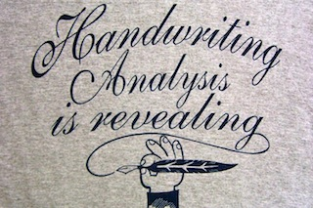
- Pressure on the page
- Formation of the loops in letters such as L, O, f, p, B, etc.
- Dotting of the letters “I, j”
- Crossing of the letter “t”
- How letters are joined
- A combination of printing and writing
- Formation of less common letters
- Size of words and letters
- Extraneous marks on the page
- Writing tool used

It can also be interesting to research the study of graphoanalysis, which involves the premise that handwriting reveals personality.

