Categorizing Prints
There is a deposit of moisture, salt and oil on your skin and the ridges of your fingertips. When we touch things, the oil on our fingers leaves a print mark in the pattern of the ridges of our fingerprints.
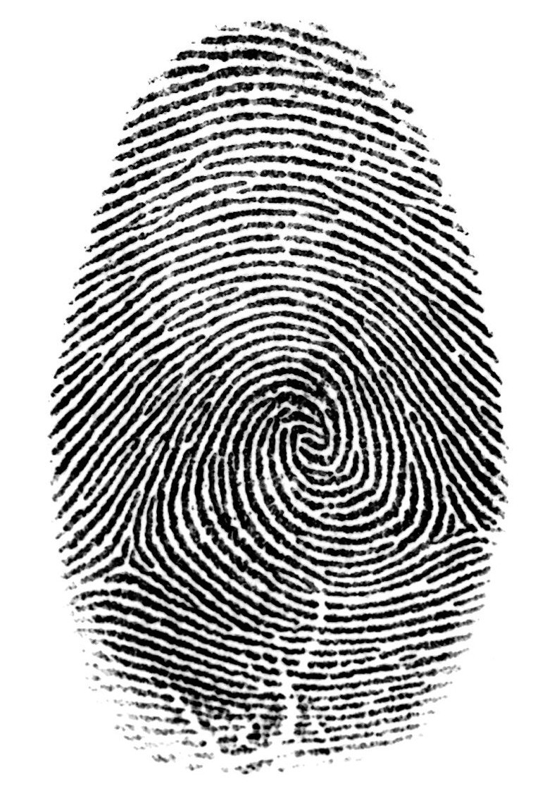
When the police identify fingerprints, the first thing they do is look at the pattern of the print i.e., loop, whorl, arch or composite. Once they have a matching pattern, they look for unique features of a print to help them match a suspect to the fingerprints found at the scene of a crime. In order for the print to be considered “a match” they must have a number of ridge characteristics in common. The following are four ridge characteristics they look for in a fingerprint: Bifurcation (fork), Ridge Endings, Island, Lake.

