Activity: More Wires
In this activity, you will construct a closed circuit using two wires and will diagram the components of a circuit symbolically.

Materials: (per student or student group)

- 1 D-cell battery
- 2 insulated copper wires stripped 2 cm on either end, (30 cm long)
- 1 flashlight bulb
Task:
Light the bulb using two wires without touching the bulb to the battery.
Then, draw one such arrangement on Master #8, labeling components carefully.
Master #7
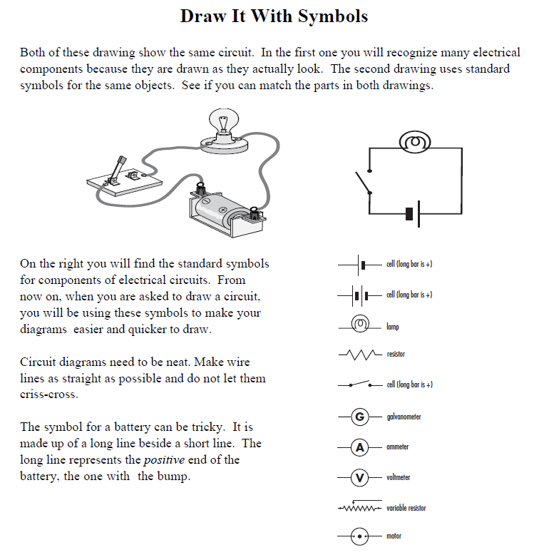
Master #8
