Activity: Will It Light?

In this activity, you will predict and test whether a bulb will light when shown a representation of an assembly of battery, bulb and wire.

Materials: (per student or student group)

- 1 D-cell battery
- 1 1.5 volt bulb
- 1 insulated copper wire stripped at both ends (30 cm long)
Complete the table (use a check mark) and questions.
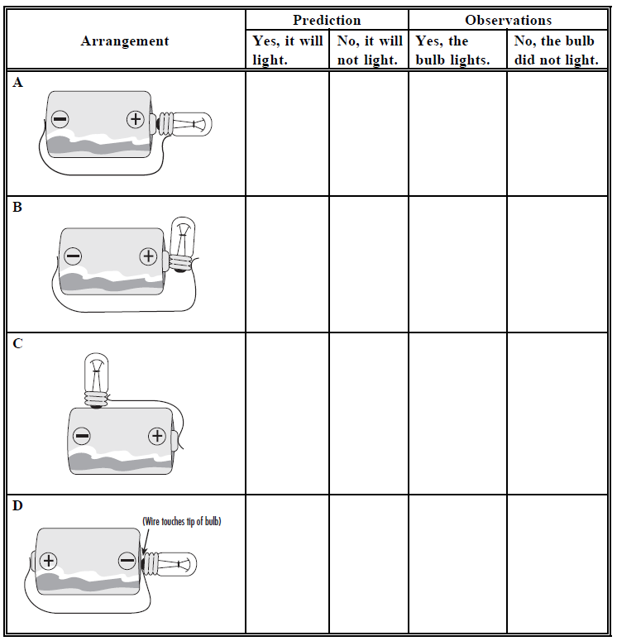

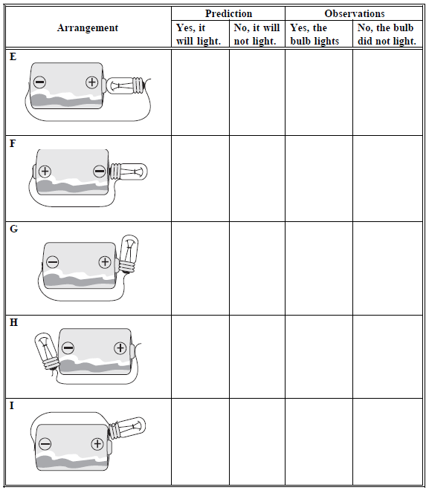

- What parts of the bulb have to be contacted by the battery or wire?
_________________________________________________________________________

- Which parts of the bulb are not affected by contact with the battery or wire?
_________________________________________________________________________

- Which parts of the battery have to make contact with the bulb or wire?
_________________________________________________________________________

- Which parts of the battery are not contacted in lighting the bulb?
_________________________________________________________________________

