Activity: Lights On!

At the end of this activity, you will demonstrate a procedure for lighting a bulb using wire and a D-cell battery.
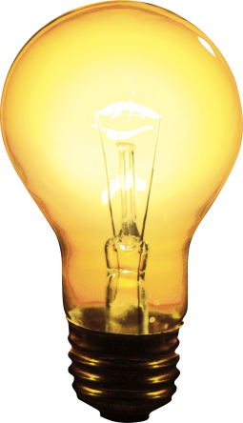
Materials: (per student or student group)

- D-cell battery
- 1.5 volt bulbs
- insulated copper wire stripped at both ends (30 cm long)

Task:
Use the materials provided to light the bulb.
Questions after completing the task:
1. What kinds of connections were used? ____________________________________________________________________________________________________________________________________________________________

2. Was there more than one way to accomplish the task? ____________________________________________________________________________________________________________________________________________________________

3. What seemed to be the locations on the battery and the bulb that were important in causing the bulb to light? ____________________________________________________________________________________________________________________________________________________________

