Natural Occurring Electricity

Static electricity is created whenever a material with loosely bonded electrons (hair, fur, nylon, silk) rubs against a non-conducting material that strongly attracts electrons (plastic, rubber) in a relatively dry environment. Moisture in the air (humidity) discharges static electricity as it is created.

Lightning is caused by an electrical discharge released from a thundercloud that has become electrically imbalanced. As thunderclouds churn, positive charges (protons) accumulate near the top of the cloud while negative charges (electrons) concentrate near the bottom. The separation of charges makes the cloud electrically imbalanced within itself, as well as in relation to other clouds or the ground. Lightning results when the electrical imbalance equalizes itself (negative charges jump to adjacent positively charged objects). The flash we see is caused by molecules of air that are heated by friction to the point of glowing. Heated air along the path of lightning expands and contracts quickly, creating sound waves (thunder).

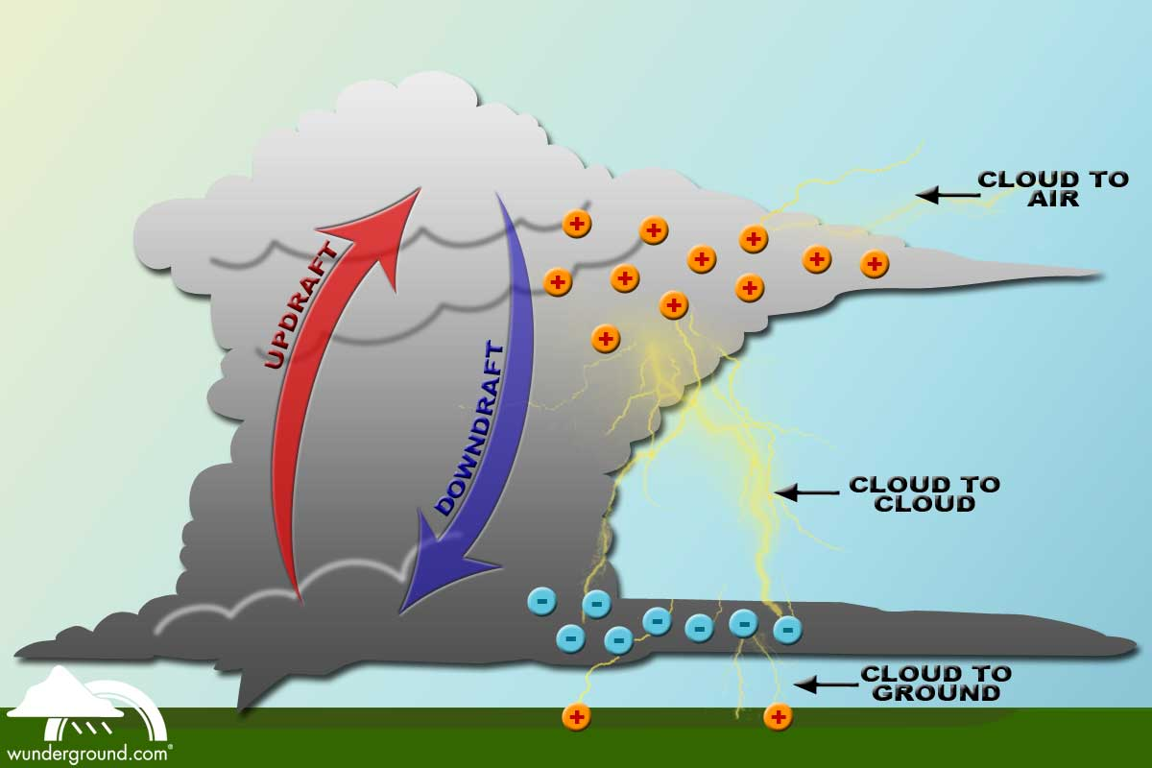

Electric eels and other electric fish have organs along the sides of their bodies that build up a charge that can be used for sensing their environment, protecting themselves against predators and obtaining food. Electric eels can produce a charge up to 600 volts which is enough to light up ten, 40-watt light bulbs. This voltage can be used to stun organisms as large as a horse or a human, causing them to stop breathing and drown.

Sharks and rays communicate using electric signals which other fish can pick up in the water. They can
detect tiny changes in their electric fields caused by the objects around them.

The human body runs on electricity that is generated when different electrically charged particles move between cells and surrounding fluids in the body. Everything you do depends on tiny electrical impulses of about 0.1V traveling through your body. Your brain operates on approximately 10 watts of electricity, the same amount required to light up a string of outdoor Christmas lights. Injuries heal faster because an electrical current begins to flow from a cut or wound which triggers cell division and makes nerves in the injured area grow faster. Your brain, nervous system, and muscles work because of electricity. Your nerves act like a telephone line transmitting tiny electrical impulses to and from your brain, however, the amount of electricity used to send these messages is not even strong enough to light a tiny LED (light-emitting diode that generally uses less than 2V). A larger electrical current, such as the 120V household current, will over ride your body’s low voltage current causing a disruption of message transmission. Thus a shock from an electrical appliance may cause the muscles and brain to stop functioning appropriately and could result in death.

