It’s an Electric World!

Natural Occurring Electricity | Electricity Produced or Used by Humans
- Lightning  - electric eels  - electric rays  - electric catfish  - fireflies  - static electricity  - brain and nerve impulses  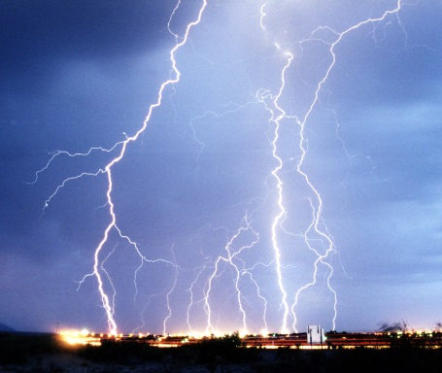 | - Toasters  - light bulbs  - fans  - cars (ignition, lights, radio, etc.)  - furnaces  - electric buses  - Carnival rides  - Gaming systems  - Computers  - electric construction tools (saws, sanders, paint machines, etc.)  - street lighting  - traffic signals  - cash registers  - banking terminals  - school buzzers  - clocks  - automatic doors  - escalators  - electromagnets for moving scrap metal  