November 29, 2016
Why did People Settle in the Atlantic Region?
- Mi’kmaq, Maliseet, and Beothuk – fished, hunted, gathered
- They moved place to place to take advantage of seasons- lived along coast most of the year (New Brunswick, Nova Scotia, part of Quebec, later parts of Nfld.)
- Canoed
- Summer = coast, winter = hunt caribou
- WATER important for all First Nations

NATURAL RESOURCES
- First Nations did not plant crops or keep herds of animals because they moved so much and did not build permanent homes.
- Mi’kmaq homes called WIGWAMS (Mi’kmaq word for “dwelling”)- made from spruce poles and birch bark. Tree roots were used for binding poles and sewing the bark together.
- Water, forests, and land provided for the people- different foods, berries, clams and meat were produced in each season.
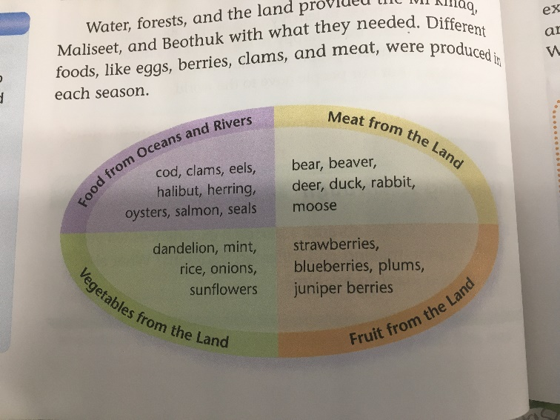
How Do We Know About the Past?
Archeologist- someone who studies the way people once lived by looking at their homes, tools, clothing etc. Often these are the only clues we have about how people lived.
- You can also read journals, diaries, letters, listen to oral history
Beothuks
- No longer exist
- Died after Europeans arrived in Nfld. Many from diseases that came with the Europeans.
- Some starved, and some were killed by settlers who wanted their land

