Atlantic Region

During a heavy snowstorm on January 10,1996 the rescue coordination center in Halifax 24 crew members were on that ship and in a storm that hade brewed up the ship got damaged and the crew would have surely died. But rescue teams acted quickly. A helicopter flew to the ship and dropped survival suits down to the crew. The crew put the suits on minutes later a boat came to save the crew from dyeing thankfully all 24 members where saved. People of the Atlantic region are familiar with the story of the joint rescue on that day and many to come will learn about it also.
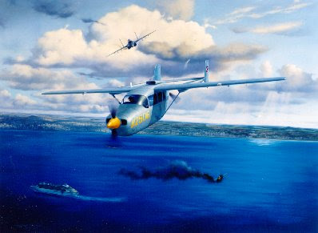

The Natural resources are Oil, Fish, Oceans, Farmland.
The Mi’kmaq and Maliseet First nations have always lived in this region. The Beothuk First nations lived in Newfoundland but sadly no longer exist. The first Europeans to come to the Atlantic region were the Vikings.


Fun Fact: the Atlantic region covers parts of the provinces of Nova Scotia, New Brunswick, the island of Newfoundland, Québec and P.E.I
