Monday, November 21, 2016
JINGLE all the Way to St. John XXIII!
Santa’s Mailbox is Piling up with Student Letters

Jessica MacDonald
St. John XXIII Alley

Ho Ho Ho! Students of St. John XXIII wrote letters to Santa last Friday afternoon. The idea of having the whole school write letters to Santa, was initiated during One Voice, a spiritual gathering of the student body. It was decided that the letters were to be written so that students can raise money, have awareness of people who may need hope, and lastly, to help improve writing skills.

The students of St. John XXIII raised money by writing letters to Santa. For every letter written, $1 was to be donated towards the charity, Santa’s Anonymous. The school built a partnership with Toy ‘r’ Us. The large toy company, has agreed to donate money according to how many letters St. John XXIII has written. In total, the school wrote 776 letters to Santa. Therefore, $776 was donated to Santa’s Anonymous.

“This fundraiser was so much fun. It felt very rewarding knowing that kids will be able to get Christmas presents during the holidays,” said a Grade 5 student of St. John XXIII, Dominik Murphy.
During the school’s program, One Voice, teachers and students discussed people who were less fortunate and who may need some hope for this upcoming holiday. The students were asked to reflect on the questions, “how can you bring hope to others?” There was one particular student, Meghan Krate, who suggested the social justice project. From there, the whole school supported her idea.

“I know someone personally who would benefit from this social justice project. I think everyone deserves a second chance and that everyone should feel special this time of the year,” explained Meghan Krate.

Although, the main focus was to raise money for Santa’s Anonymous, teachers felt this was also great opportunity to teach the students how to write letters in Language Arts. In addition, the project was integrated into the students’ Religion and Health curriculum.

“I am so proud of my students for taking the initiative to begin this social justice project on their own. It is important that students be the change that they want to see in the world,” said Mrs. Valdez, a Grade 6 teacher.

Next week, St. John XXIII will be presenting a cheque to Santa’s Anonymous during their weekly One Voice assembly. Other social justice projects that will be occurring at St. John XXIII include: a Food Drive, Toonie for Toes, and Sign of Hope. For more information about Santa’s Anonymous, please visit the website www.santasanonymous.ca .

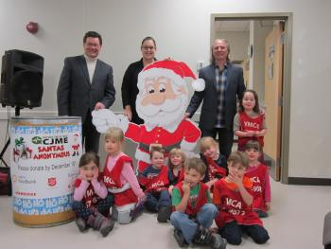

St. John XXIII staff and Grade 1 students celebrate the amount of letters written for Santa. –Ashley McGee, St. John XXIII Alley

