Deciduous or coniferous?
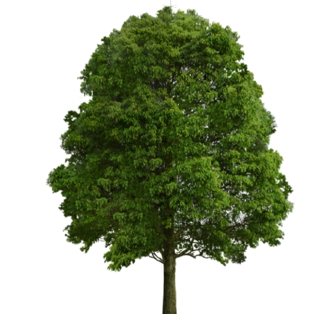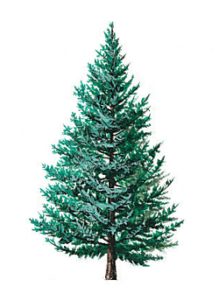

Types of trees
 | Deciduous | coniferous
Shedding of Leaves | - Shed leaves in fall | - Shed continuously (most do not shed leaves in one season)
Shape of Leaves | - Broad-leafed or needle shaped | - Needle-shaped leaves
Water Retention | - Leaves waxy topside and large surface area on underside, causing moisture loss | - Thick, waxy coating reduces water loss from transpiration
Temperature Resistance | - Do not withstand temperature extremes | - Do withstand temperature extremes

Deciduous- loses its leaves in the fall.
Coniferous- cone baring trees.

* A larch (tamarack) is both deciduous and coniferous. It loses its leaves in the fall and is also cone bearing.
Leaf Classification
Leaf Types
Simple Leaves | 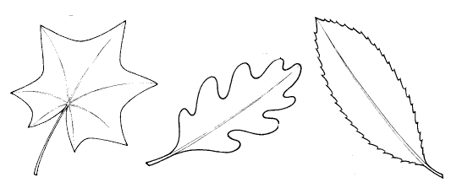
Compound Leaves (more than one blade on a petiole) | 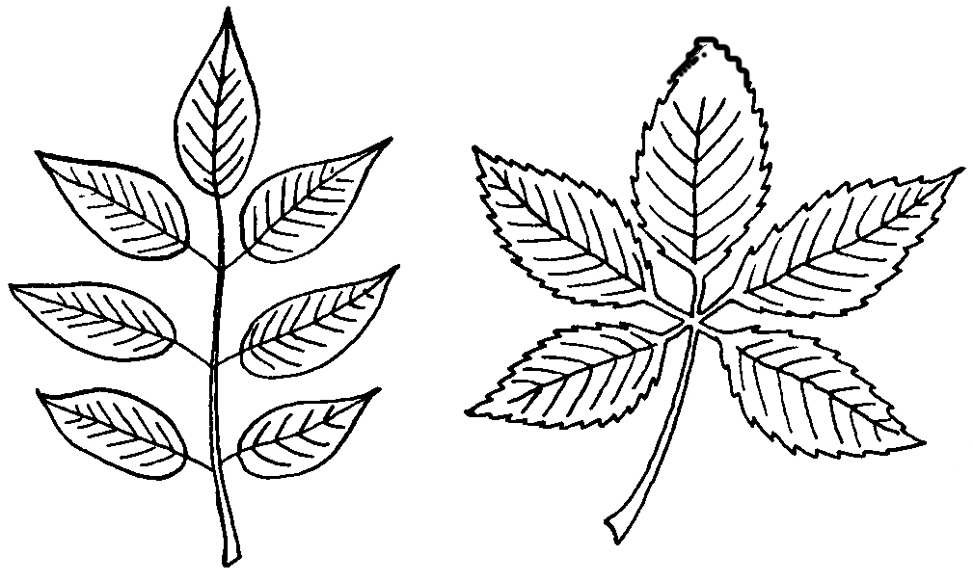
Double Compound Leaf | 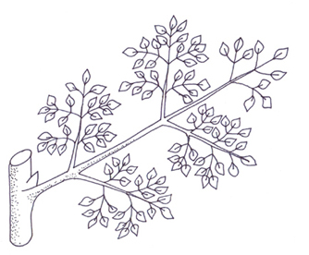
Needle Leaf | 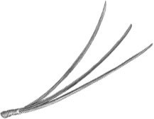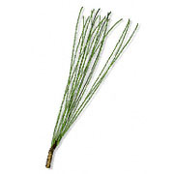
Leaf Classification
Leaf shapes
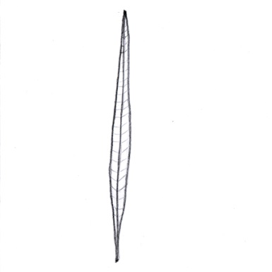  Linear |  | 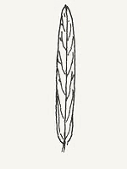  Oblong |  |  | 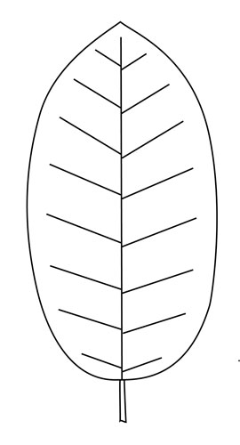  Oval |  |  | 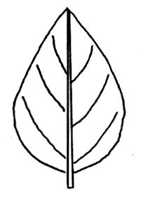  Ovate |  |  |  | 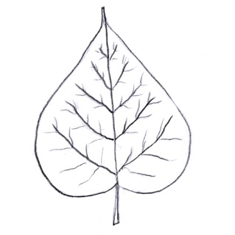  Cordate (heart-shaped)
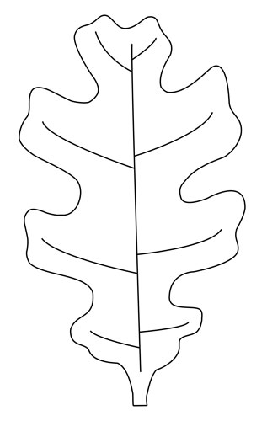  Lobed |  | 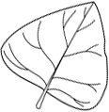  Deltoid  (Triangular) |  |  | 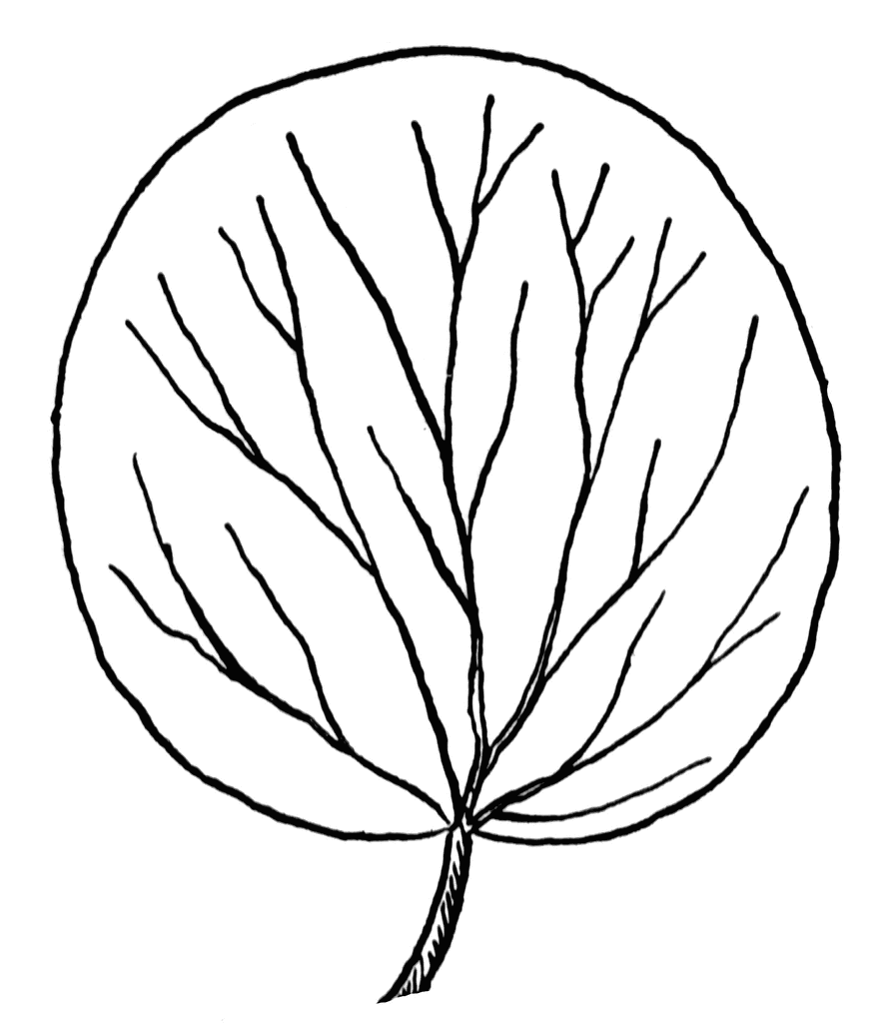  Orbicular (Round) |  |  | 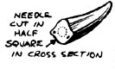  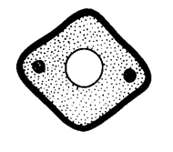  Four Sided Needle |  |  |  | 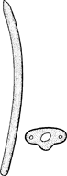  Flattened Needle
Leaf shapes
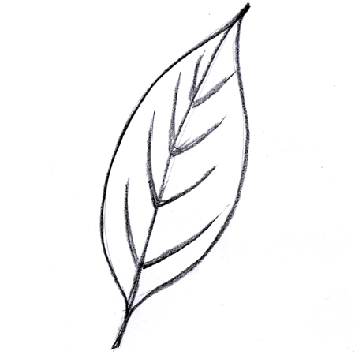  Smooth |  |  | 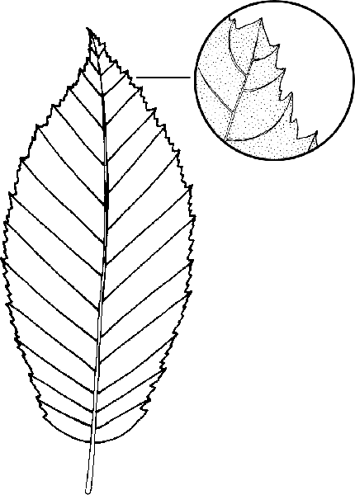  Fine-toothed |  |  |  | 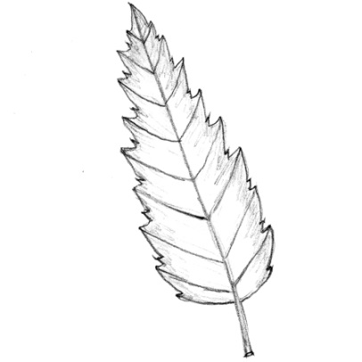  Coarse-toothed or Serrated |  |  | 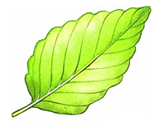  Scalloped or Wavy
Leaf arrangements
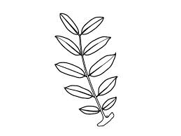  Opposite | 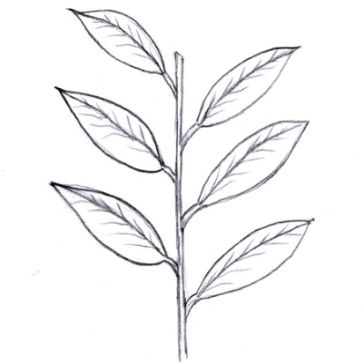  Alternate |  |  |  |  | 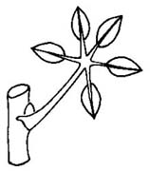  Whorl |  |  |  |  | 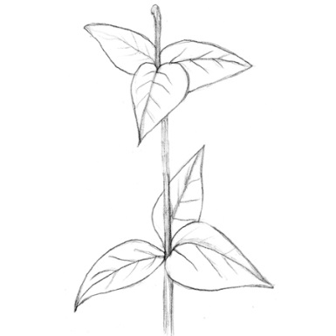  Basal
Needle arrangements and types
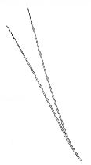  In bundles of two |  |  |  | 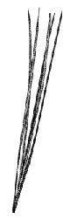  Bundles of Fiv e |  |  |  |  | 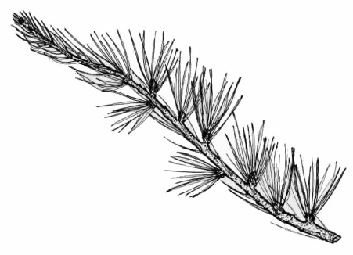  In Clusters of More Than Five
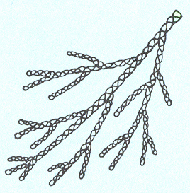  Scale-Like |  |  |  |  |  | 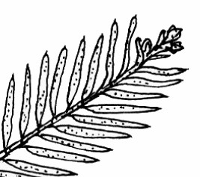  Singly on a Twig

Leaf classification exercise
Directions:
Beside each leaf picture record
- Type of leaf
- Shape of leaf or needle
- Margin type or arrangement or needles

- Willow  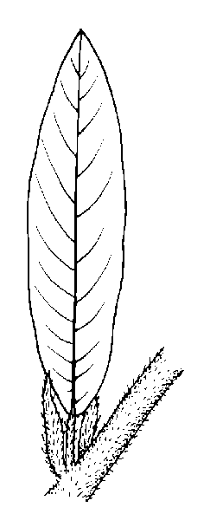  - ____________________  - ____________________  - ____________________ | - Plains Cottonwood           

