Name: ____________________
Date: ____________________

Grade 6 Social Studies: Chapter 7: Making a Just and Fair Canada

How Are Our Constitutional Rights Protected?

- How do we keep our rights and freedoms safe? (Page 164)
- ______________________________________________________________________________________________________________________________________
- ______________________________________________________________________________________________________________________________________
- ______________________________________________________________________________________________________________________________________
- ______________________________________________________________________________________________________________________________________
- ______________________________________________________________________________________________________________________________________

Why Are Collective Rights Protected?

- Define COLLECTIVE RIGHTS and provide an example(s). (Page168)
________________________________________________________________________________________________________________________________________________________________________________________________________________________

- Define MINORITY RIGHTS and provide an example(s). (Page 168-169)
________________________________________________________________________________________________________________________________________________________________________________________________________________________


Caption: (Page 169)
_______________________________
_______________________________
_______________________________

Decisions in Democracy >DEMOCRACY AND LANGUAGE RIGHTS
- Copy the pie graph on page 170. Don’t forget to include the title and labels.
Conclusion(s): ____________________________________________________________________________________________________________________________________________

- Complete the table. (Page 170)

Important Law/Act | Details
British North American Act, 1867

Official Languages Act, 1969

Canadian Charter of Rights, 1982
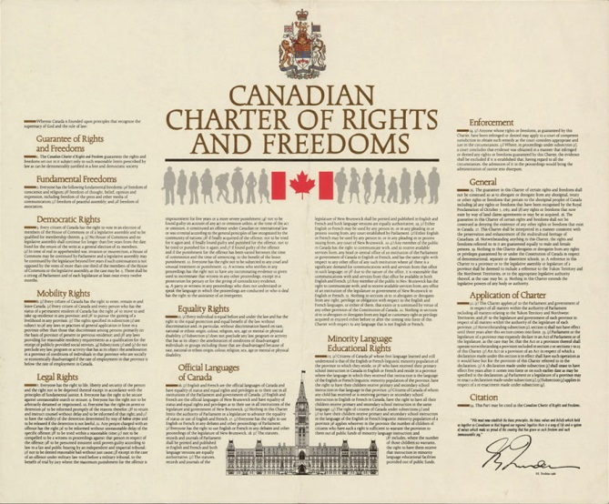


VS.
Anglophones
Francophones

Explain the above picture. Refer to Page 171.
______________________________________________________________________________________________________________________________________________________________________________________________________________________________________________________________________________

